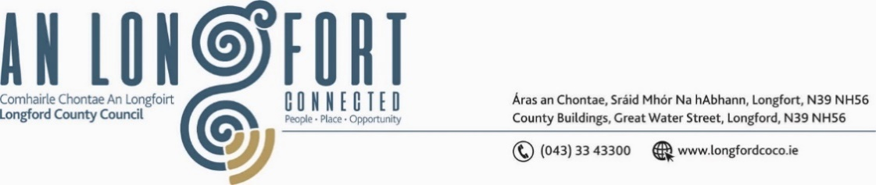

***BALLYMAHON MUNICIPAL DISTRICT***

**24 June 2024**

**To: Each Member of Ballymahon Municipal District.**

A Chomhairleoir,

You are requested to attend the Annual Meeting of Ballymahon Municipal District to be held in **The Council Chamber on Monday, 24 June 2024 at 4pm** to transact business, as set out on the Agenda hereunder.

Mise le meas,

______________

**Claire McNabola,**

**Meetings Administrator.**

**C L A R**

**1**.      Election of Cathaoirleach.

**2.**      Election of Leas Cathaoirleach .

**3.**       Nominations to Committees – referred from Longford County Council

          2024 Annual Meeting

**4**.      Fix date and time of Ballymahon Municipal District meetings.